Lungs in frog are simple sacs almost like balloon when they are fully expanded. The inner surface of lung is increased by thin walled air chambers. The walls of these air chambers are richly supplied with capillaries. These blood containing areas in the lungs are the main sites for gaseous exchange. The consumed air after gaseous exchange moves out of the lungs through the nostrils. The removal of consumed air out of the lungs, after gaseous exchange has occurred, is called **exhalation or expiration** (Fig. 13.6).

##### Respiration in birds

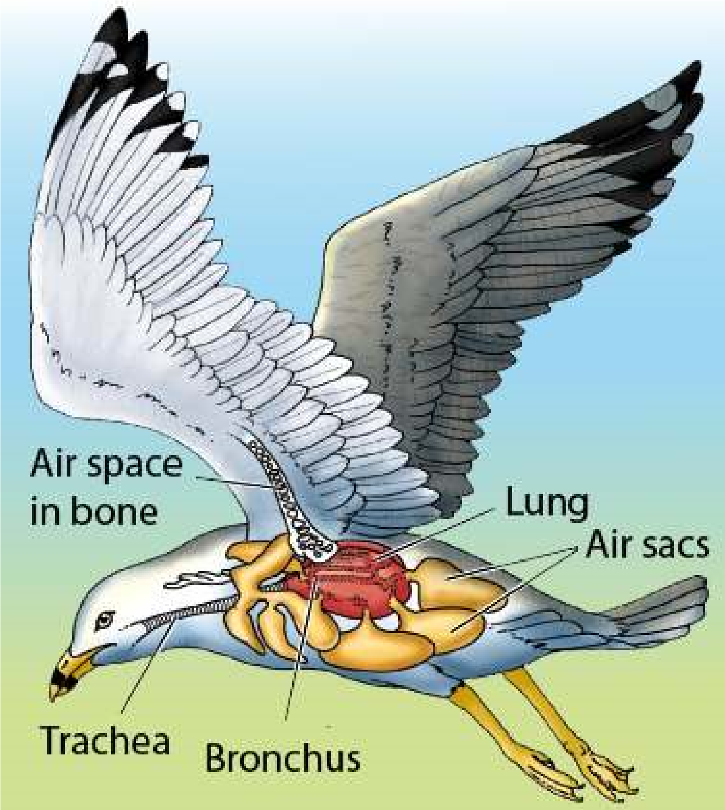Respiratory system in birds is the most eicient and elaborate. The birds are very active animals with high metabolic rate, and thus need large amount of oxygen. The respiratory system in the birds is so arranged that there is one way low of the air through the lungs and the air is renewed after inspiration. In the lungs of birds, tiny thin walled ducts called **parabronchi** are present instead of alveoli. These parabronchi are open at both ends and the air; is constantly ventilated. The walls of the parabronchi are chief sites of gaseous exchange. The direction of the blood low in the lungs is opposite to that of the air low through the parabronchi. This counter current exchange increases the amount of oxygen which enters blood. Lungs in birds are very eicient in this respect as well, because no stale of air remains in the parabronchi.

The lungs have also developed several extensions known as air sacs which reach all parts of the body and even penetrate some of the bones. In most birds the air sacs are nine in number which become inlated by air at atmospheric pressure when the rib articulations are rotated forward and upward. The inlated air sacs act as bellows and send air into the parabronchi for gaseous exchange.

*Fig. 13.7 The Respiratory System of Bird*

*Animation 13.8: Respiration in Frog*

*Source and Credit: clipartbest*

##### Respiration in man

In man respiratory system includes lungs and air passages which are responsible for carrying fresh air to the respiratory sites.

##### Air Passage Ways

Air passage ways consist of nostrils, nasal cavities, pharynx, larynx, trachea, bronchi, bronchioles and alveolar ducts which ultimately lead into the alveolar sac. Nasal cavities are lined with mucous membrane of ciliated epithelium. Each nasal cavity is subdivided into three passage ways by the projection of bones from the walls of the internal nose. Air enters the nasal cavity through nostril and the larger dust particles are trapped by the hair and mucus in the nostrils. Air, while passing through the nasal cavity, becomes moist, warm and iltered of smaller foreign particles by mucous membrane. The nasal cavity leads into the throat or pharynx by two internal openings. The pharynx is a muscular passage lined with mucous membrane. The air is channelized from the pharynx into the larynx.

The **larynx** or voice box is a complex cartilaginous structure surrounding the upper end of the trachea. One of the cartilages, the epiglottis has a muscularly controlled, hinge-like action and serves as a lid which automatically covers the opening of the larynx during the act of swallowing so as to prevent the entry of food or liquids into the larynx. The opening of larynx is called glottis and is also lined with mucous membrane. In the glottis the mucous membrane is stretched across into two thin edged ibrous bands called **vocal cords,** which help in voice production, when vibrated by air.

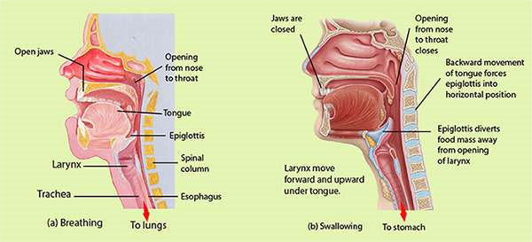

*Fig. 13.8 Events in the throat associated with breathing (a) and swallowing (b). The commonly held belief that the epiglottis closes downward upon the larynx when food is swallowed is not quite true. The closure is probably never complete; the degree of closure is determined partly by the backward movement of the tongue during swallowing (which forces the epiglottis into a more or less horizontal position) and partly by the upward movement of the larynx (which brings it up under the epiglottis). Food does not enter the partly open larynx and obstruct breathing primarily because the epiglottis diverts the food mass to one side of the opening and safely down the esophagus.*

The **trachea** **or** **wind Pipe** is a tubular structure lying ventral to the oesophagus and extends to the chest cavity or thorax where it is divided into right and left bronchi. In the wall of trachea there are a series of C shaped cartilage rings which prevent the trachea from collapsing and keep the passage of air open. Each bronchus on entering the lung divides and subdivides progressively into smaller and smaller **bronchi**. When the smaller bronchi attain a diameter of one mm or less, then they are called **bronchioles**. Bronchi have thesame cartilage rings as the trachea, but the rings are progressively replaced by irregularly distributed cartilage plates and the bronchioles totally lack cartilages. Bronchioles are made up of mainly circular smooth muscles.

The bronchioles continue to divide and subdivide deep into the lungs and inally open into a large number of air-sacs. Air-sac is the functional unit of the lungs. Each air-sac consists of several microscopic single layered structures called **alveoli**. Overlying the alveoli there is a rich network of blood capillaries to produce an excellent site for the exchange of gases.

The lungs are closed sacs that are connected to the outside by way of the trachea and the nostrils or mouth. Lungs are spongy because of the presence of millions of alveoli. Lungs are placed in the chest cavity. Chest cavity is bounded by ribs and muscles on the sides. The loor of the chest is called **diaphragm**.Diaphragm is a sheet of skeletal muscles. Lungs are covered with double layered thin membranous sacs called **pleura (Fig. 13.9).**

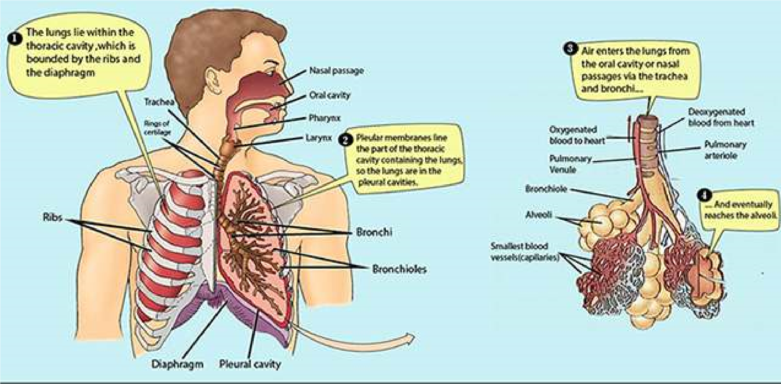

*Fig. 13.9 Human respiratory organs*

*Animation 13.9: Respiratory System*

*Source and Credit:* [*pleasanton.k12*](http://www.pleasanton.k12.ca.us/avhsweb/thiel/apbio/review/respiration.html)

**MECHANICS OF VOLUNTARY AND INVOLUNTARY**

### REGULATION OF BREATHING IN MAN

Breathing is a process in which fresh air containing more oxygen is pumped into the lungs and air with more carbon dioxide is pumped out of the lungs. In other words breathing is a mechanical process consisting of two phases, inspiration and expiration. During inspiration, fresh air moves in and in expiration air with low O2 and high CO2 content moves out of the lungs. During rest breathing occurs rhythmically at the frequency of 15 to 20 times per minute in humans. To understand the mechanism of breathing we should keep in mind three aspects related to lungs and associated structures.

1. Lungs are spongy in nature. The lungs themselves neither pull air in nor can they push it out. During inspiration passive expansion of elastic lungs occurs and expiration is due to a passive contraction of lungs.
2. The loor of the chest cavity is diaphragm, which is a muscular sheet. The snape of the diaphragm is more domelike when its muscles are relaxed. On the other hand when the muscles of the diaphragm contract its shape becomes less domelike.
3. Walls of the chest cavity are composed of ribs and intercostal muscles. When muscles between the ribs contract, the ribs are elevated and when muscles between ribs are relaxed the ribs settle down.

#### Inspiration

During inspiration the space inside the chest cavity is increased in two ways. Firstly, the muscles of ribs contract and elevate the ribs upwards and forwards and secondly, the muscles of diaphragm

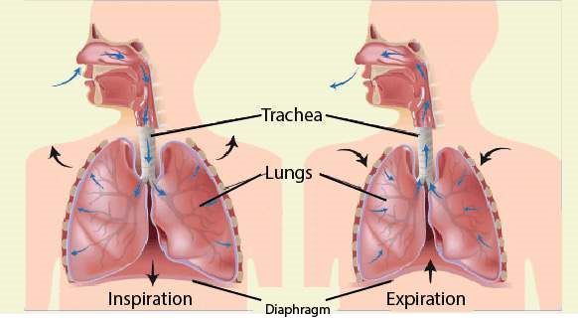

*Fig. 13.10 Movement of Diaphragm*

also contract and diaphragm becomes less domelike. This downward movement of diaphragm and outward and upward movement of the ribs causes increase in the chest cavity and reduces pressure. When the pressure from the lungs is removed they expand. With the expansion of the lungs vacuum is created inside the lungs in which the air rushes from the outside due to higher atmospheric pressure. This is called inspiration (Fig. 13.10,13.11)

##### Expiration

During expiration the muscles of ribs are relaxed and the ribs move downward and inward. In this way from the sides of chest cavity the space becomes less. At the same time the muscles of diaphragm also relax becoming more domelike *In Premature infant,* **respiratory distress syndrome** *is* and the chest cavity is also reduced from the loor. *common, especially for infant with a gestation age of less*

This reduction in space of the chest cavity exerts *than 7 months. This occurs because enough surfactant(mixture of lipoprotein molecules produced by the secretary* pressure on the lungs. When lungs are pressed the *cells of the alveolar epithelium which forms a layer over the* qir inside lungs moves out of the lungs and this is *surface of the luid within the alveoli to reduce the surfacetension) is not produced to reduce the tendency of the lungs* expiration. (Fig. 13.10, 13.11) *to collapse.*

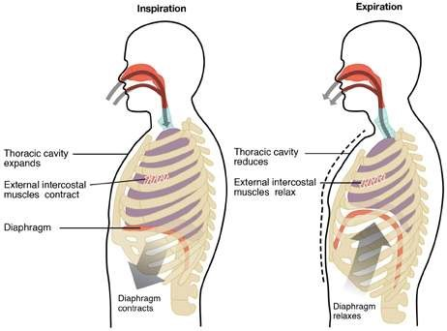

*Fig. 13.11*

### TRANSPORT OF RESPIRATORY GASES

Intake of oxygen and release of carbon dioxide by blood passing through capillaries of alveoli is brought about by the following factors.

1. Difusion of oxygen in and carbon dioxide out occurs because of diference in partial pressures of these gases.
2. Within the rich network of capillaries surrounding the alveoli, blood is distributed in extremely thin layers and, therefore, exposed to large alveolar surface.
3. Blood in the lungs is separated from the alveolar air by extremely thin membranes of the capillaries and alveoli.

#### Transport of Oxygen

In human beings the respiratory pigment is haemoglobin. It is contained in the red blood corpuscles. Haemoglobin readily combines with oxygen to form bright red oxyhaemoglobin. Oxyhaemoglobin is unistable and splits into the normal purple-red coloured haemoglobin and oxygen in the conditions of low oxygen concentration and less pressure.Carbonic anhydrase enzyme present in R.B.C. facilitates this activity. In this way haemoglobin acts as an eicient oxygen carrier. A small proportion of oxygen also gets dissolved in the blood plasma.

#### Hb + O2 m HbO2

Haemoglobin can absorb maximum oxygen at the sea level. The maximum amount of oxygen which normal human blood absorbs and carries at the sea-level is about 20ml/100ml of blood. This is the maximum capacity of haemoglobin for oxygen when it is fully oxygenated. Under normal conditions, blood of alveoli of the lungs is not completely oxygenated. When an oxygen tension is 115mm mercury, haemoglobin is 98 percent saturated and, therefore, contains 19.6 ml of oxygen per 100ml of blood. This means that haemoglobin can be almost completely oxygenated by an oxygen pressure of 100 mm mercury, which is present in the lungs. Any higher oxygen pressure would have the same result. When oxygen pressure falls below 60 mm mercury, as in many cells and tissues, the oxygen saturation of haemoglobin decreases very sharply. This results in the liberation

*As a scuba diver descends in the sea, the pressure of the* of large quantities of oxygen from haemoglobin. In *water on his body prevents normal expansion of the lungs.* this way in the tissue where oxygen tension is low *To compensate, the diver breaths pressurized air from air* oxyhaemoglobin dissociates rapidly. *pressure.cylinders, which has a greater pressure than sea level air*

There are three important factors which afect the capacity of haemoglobin to combine with oxygen.

##### 1. Carbon dioxide

When carbon dioxide pressure increases, the oxygen tension decreases, the capacity of haemoglobin to hold oxygen becomes less. In this way increased carbon dioxide tension favours the greater liberation of oxygen from the blood to the tissue.

##### 2. Temperature

Rise in temperature also causes a decrease in the oxygen-carrying capacity of blood, e.g., in the increased muscular activity.

##### 3. pH

The pH of blood also inluences the degree to which oxygen binds to haemoglobin. As the pH of the blood declines, the amount of oxygen bound to haemoglobin also declines. This occurs because decreased pH results from an increase in hydrogen ions, and the hydrogen ions combine with the protein part of the haemoglobin molecules, causing a decrease in the ability of haemoglobin to bind oxygen. Conversely, an increase in blood pH results in an increased ability of haemoglobin to bind oxygen.

##### Transport of Carbon Dioxide

Carbon dioxide is more soluble than oxygen and *Carbon dioxide which is much more important than oxygenas a regulator of normal alveoler ventilation (Breathing) but* dissolves freely in the tissue luid surrounding the *under certain circumstances a reduced P02 (partial pressure* cells. From the tissue luid, dissolved carbon dioxide *of the oxygen) in the arterial blood does play an important* passes to the plasma within the blood capillaries. *stimulatory role especially during conditions of shock.*

Carbon dioxide is transported in the blood in several diferent states.

1. Some of the carbon dioxide (about 20%) is carried as carboxyhaemoglobin. Carboxyhaemoglobin is formed when carbon dioxide combines with amino group of haemoglobin.
2. Other plasma proteins also carry about 5% carbon dioxide from the body luids to the capillaries of lungs.
3. About 70% carbon dioxide is carried as bicarbonate ion combined with sodium in the plasma. As carbon dioxide from tissue luid enters the capillaries it combines to form carbonic acid.

**Corbonic anhydrase 7**

##### CO2 + h2O H2CO3

The carbonic acid splits quickly and ionizes to produce hydrogen ions and bicarbonate ions. **7**

##### H2CO3 H+ + HCO3-

When blood leaves the capillary bed most of the carbon dioxide is in the form of bicarbonate ions. All these reactions are reversible. In the lungs bicarbonate ions combine with hydrogen ions to form carbonic acid which splits into water and carbon dioxide. It is this carbon dioxide which difuses out from the capillaries of the lungs into the space of alveolar sac. **7 7**

##### HCO3- + H+ H2CO3 CO2 + H2O

4. Small amount of carbon dioxide is also carried by corpuscles combined with potassium.

###### Carbon Dioxide Concentration in Arterial And Venous Blood

It has been found that arterial blood contains about 50 ml of carbon dioxide per 100 ml of blood whereas venous blood has 54 ml of carbon dioxide per 100 ml of blood. In this way each 100 ml of blood takes up just 4 ml of carbon dioxide as it passes through the tissues and gives of 4 ml of carbon dioxide per 100 ml of blood as it passes through the lungs.

**Respiratory Disorders**

###### Cancer

Many problems in the respiratory system can take place if inside lining is exposed continuously to unhealthy air, containing smoke and other pollutants. Lung cancer is one of the most serious diseases of respiratory system. Cancer or carcinoma is basically malignant tumor of potentially unlimited growth that expands locally by invasion and systemically by metastasis. Cancer can occlude respiratory passages as the tumor replaces lung tissue. Smoking especially in young adults is the most potential threat of lung cancer. The chances of lung cancer are ten times more in those persons who smoke or live in smoky and congested areas as compared to those who do not smoke. It is now estimated that 90% of lung cancer is caused by smoking. Recent research indicates that more than ten compounds of tar of tobacco smoke are involved in causing cancer.

###### Tuberculosis

Tuberculosis is a disorder of respiratory system. In fact, it is the general name of a group of diseases caused by *Mycobacterium tuberculosis*. Pulmonary tuberculosis is a disease of lungs in which inside of the lung is damaged resulting in cough and fever. It is more common in poor people. Malnutrition and poor living conditions facilitate *Mycobacterium* to grow. The disease is curable with proper medical attention. It is a contagious disease.

###### Asthma

Asthma is a serious respiratory disease associated with severe paroxysm of diicult breathing, usually followed by a period of complete relief, with recurrence of attack at more or less frequent intervals. It is an allergic reaction to pollen, spores, cold, humidity, pollution etc which manifests itself by spasmodic contraction of small bronchiole tubes. Asthma results in the release of inlammatory chemicals such as histamines into the circulatory system that cause severe contraction of the bronchiole.

###### Emphysema

Emphysema is a break down of alveoli. This respiratory problem is more common among smokers. The substances present in the smoke of the tobacco weaken the wall of alveoli. The irritant substances of smoke generally cause “smoker’s cough” and *In patients with emphysema, alveolar walls degenerate* coughing bursts some of the weakened alveoli. In the *and small alveoli combine to form larger alveoli. The result* result of constant coughing the absorbing surface of *is fewer alveoli, but alveoli with an increased volume and* the lung is greatly reduced. The person sufering from *decreased surface area. Although the enlarged alveoliare still ventilated, there is inadequate surface area for* emphysema cannot oxygenate his blood properly and *complete gas exchange, and the physiological dead air* least exertion makes him breathless and exhausted. *space is increased.*

Emphysema produces increased airway resistance because the bronchioles are obstructed as a result of inlammation and because damaged bronchioles collapse during expiration, trapping air within the alveolar sacs.

Role of Respiratory Pigments

Various types of respiratory pigments are present in diferent animals. The pigment combines with oxygen reversibly and increase the oxygen carrying capacity of the blood. Haemoglobin is the most important protein present in many animals including man. Haemoglobin in man increases the oxygen carrying capacity of the blood to about 75 times. You are familiar with its chemical composition.

Myoglobin is haemoglobin-like iron-containipg protein pigment occurring in muscle ibers. Myoglobin is also known as muscle haemoglobin. It serves as an intermediate compound for the transfer of oxygen from haemoglobin to aerobic metabolic processes of the muscle cells. It can also store some oxygen. Myoglobin consists of just one polypeptide chain associated with an ironcontaining ring structure which can bind with one molecule of oxygen. The ainity of myoglobins to combine with oxygen is much higher as compared to haemoglobin.

##### Diving relex

Aquatic mammals especially cetaceans can stay in the depth of the ocean for about two hours without coming up for air.

Diving mammals have almost twice the volume of blood in relation to their body weight as compared to non divers. Most of the diving mammals have high concentration of myoglobin in their muscles. Myoglobin binds extra oxygen.

When a mammal dives to its limit the diving relex is activated. The breathing stops, the rate of heart beat slows down to one tenth of the normal rate, theconsumption of oxygen and energy is reduced. The blood is redistributed but most of the blood goes to the brain and heart which can least withstand anoxia. Skin muscles and digestive organs and other internal organs receive very little blood while an animal is submerged because these areas can survive with less oxygen. Muscles shift from aerobic to anaerobic respiration.

###### Lung capacities

In an adult human being when the lungs are fully inlated the total inside capacity of lungs is about 5 litres. Normally when we are at rest or asleep the exchange is only about half a litre. The volume of air taken inside the lungs and expelled during exercise is about 3.5 litres. In other words, there is a residual volume of 1.5 litres even during exercise which cannot be expelled.

Normally, at rest we inhale and exhale 15-20 times per minute. During exercise the breathing rate may rise to 30 times per minute. The increased rate and depth of breathing during exercise allows more oxygen to dissolve in blood and supplied be to the active muscles. The extra carbon dioxide which the muscle puts into the blood is removed by deep and fast breathing. There is a little change in the composition of inhaled and exhaled air during rest or exercise in most of the constituents of the air as seen in the Table 13.1

**Table 13.1. Changes in the composition of the breathed air**

|  |  |  |
| --- | --- | --- |
|  | **Inhaled %** | **Exhaled %** |
| Oxygen | 21 | 16 |
| Carbon dioxide | 0.04 | 4 |
| Water vapours | variable | saturated |
| Nitrogen | 79 | 79 |

##### EXERCISE

1. **.1 Fill in the blanks**
   * 1. _____________ is the most abundant protein in the world.
     2. Haemoglobin is a complex molecule which contains 9512 atoms and __________amino acids.
     3. The opening of larynx is called _____________________.
     4. When the smaller bronchi attain the diameter of____________mm or less they are called bronchioles
     5. There are about ____________ stomata per square centimeter of leaf surface of tobacco

plant

* 1. **Write whether the statement is true or false. Correct the statement if it is false.**
     1. ATP is generated during organismic respiration .
     2. Water is a better respiratory medium than air.
     3. The earthworm does not possess specialized organs for respiration.
     4. In parabronchi of birds, the blood lows in the opposite direction of air low. (v) Ring shaped cartilages are present in trachea of man.
  2. **Short questions**
     1. How does breathing difer from respiration?
     2. How much carbon dioxide is present in venous and arterial blood?
     3. How does air always remain in the lungs of human beings?
     4. What are the products which are produced during photorespiration?

* + 1. How much denser is a water medium than air medium for exchange of respiratory gases?
  1. **Extensive questions**
     1. In what ways is air a better respiratory medium than water?
     2. What is photorespiration? Give its consequences.
     3. Describe briely the properties of respiratory surfaces in cockroach.
     4. In what ways is respiration in birds the most eicient and elaborate?
     5. Discuss the mechanical aspects of breathing in man.
     6. Write a detailed note on respiratory pigments.
     7. List the air passage way in sequence from nostrils to alveoli. Describe the structure of alveolus in detail.

CHAPTER

# 14

## Transport

*Animation 14.1:T ransport in Plant*

[*Source & Credit: m*](http://anatomyeshs.wikispaces.com/Ch.16+Respiratory+System)[*rgscience*](http://www.mrgscience.com/yr-9-topic-6-transport-in-plant.html)

### INTRODUCTION

In this chapter our main focus would be to study diferent processes involved in the transport of nutrients into the cells and removal of the wastes out of the cells. We would also study, essentially in plants and animals, the elaborate mechanism involved not only for the movement of individual molecules but also their mass transport within bodies. The processes involved for getting materials into and out of the cells are difusion, facilitated difusion, osmosis, active transport, endocytosis, exocytosis etc.

In animals, the materials move into, within and out of the body, in respiratory circulatory, digestive and excretory systems. In plants the processes of respiration, transportation, photosynthesis, absorption by roots, conduction of water, and the nutrients are involved in movement of the materials into, within and out of the body.

### NEED FOR TRANSPORT OF MATERIALS

The living organism is a complex of interactions of physical and chemical reactions involving diferent elements and molecules. All living cells or living organisms, must obtain and transport certain materials within the body and also transport and remove the wastes out of their bodies or cells.

If there were no transport systems, most of the cells of the body of a complex multicellular organism, would not be able to get the required materials and dispose of their wastes. There are no mass low systems in unicellular organisms and lower multicellular organisms.

### TRANSPORT IN PLANTS

#### Uptake and Transport of Minerals and Water A rye plant less than one meter tall

The roots of a plant not only anchor the plant body in the soil, has some 14 million branch roots but also absorb minerals and water from the soil. There are of a combined length of over 600 three types of nutrients needed by the plants, carbon dioxide, kilometers.

water and

minerals besides light to carry out photosynthesis. To get these materials, roots must provide large surface area for absorption, which is achieved by extensive branching. The roots bear a dense cluster of tiny hair like structures which are extensions of epidermal cells of roots.

These are the root hairs, which are in fact the sites where most It has been estimated that out of the uptake of water and minerals takes place. of total surface area provided by roots, 67% is provided by the root

Plants are able to sythesize all their required compounds, hairs. with the help of the minerals and H20 from soil, C02 from air,

and light energy. Most of the minerals enter the root hairs Prosopis trees of leguminoseae or epidermal cells of roots along with water in bulk low, but family have maximum depth of some are taken in by difusion, facilitated difusion, or active their roots, which is 50 metres. transport.

**Mineral absorption by roots** When inorganic or organic fertilizer

The minerals available to plants for absorption are dissolved is applied to soil, the minerals are in the soil water. Their concentration vary according to the absorbed primarily as inorganic fertility and the acidity of the soil, besides other factors. When ions. The rate of absorption of the soil minerals are not in solution but are bound by ionic each mineral by roots is essentially bonds to soil particles, they are not available to plants. independent of the rates of

**Processes involved in absorption by roots** absorption of water and of the The uptake of minerals by root cells is a combination of other minerals. Each mineral passive uptake and active uptake, involving the use of energy moves into roots at a rate in the form of ATP. The passive uptake involves difusion. The determined by such factors as minerals they also move down their concentration gradient its concentration both inside and through plasmodesmata (symplast pathway) to cells of cortex, outside the root, the ease with endodermis, pericycle and then to sap in xylem cells. From which it can passively penetrate here they are pulled up by transpiration pull to diferent parts cell membrane, and extent to of plant. which carrier molecules and active

absorption are involved.

The **difusion** of ions along with water also takes place by mass low along the apoplast pathway. Ions moving in the apoplast can only reach the endodermis, where casparian strips prevent further progress (Fig. 14.1). To cross the endodermis, ions must pass by difusion or active transport into endodermis cells, entering their cytoplasm, and possibly their vacuoles. The ions then reach the xylem cells. Difusion of ions can also take the vacuolar pathway where the ions move along their concentration gradient through the cell membranes, cytoplasm, and tonoplast (the membrane of vacuoles), and reach the dead xylem cells.

Most of ions are taken up by the roots by the process of active transport. By this method plants can take a mineral that is in higher concentration inside the root cells than in the soil solution. In this process molecules and ions move from their low concentration to their higher concentration (i.e. against the concentration gradient), through cell membrane, by the use of energy in the form of ATP. Active transport is selective and is dependent on respiration. Some ions move by passive as well as by **active transport.**

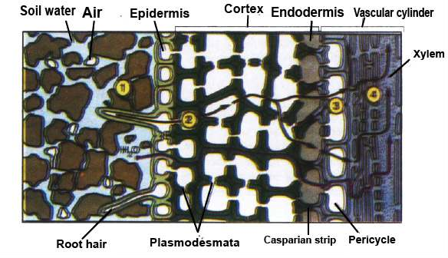

*Fig.14.1 Mineral and water uptake by roots. The Casparian strip separates the extracellular space in the root into two compartments: an outer compartment that is continuous with the soil water, and an inner compartment that is continuous with the inside of the conducting cells of the xylem. The black lines show a pathway for both water and mineral; the blue line is an alternative pathway for*

*water alone.*

*Animation 14.2*

[*:*](https://www.youtube.com/watch?v=Dtsen_YNwVk)

*transpu*

[*l*](https://www.youtube.com/watch?v=Dtsen_YNwVk)

*Source and Credit:*

*m*

*sseconisseniorbiology*

**Symbiotic Relationship helps plants acquire nutrients.**

One of the important nutrient N2 is almost always in short supply both in rock particles and in the soil water.

Most plants have evolved beneicial relationship with other organisms that help the plants acquire these scarce nutrients. Examples include: Mycorrhize and nitrogen ixing bacteria in root nodules of legumes.

**Mycorrhizae help in uptake of minerals**

The fungal associations with roots of higher plants, help mineral uptake by the plant.

The fungi facilitate the uptake of phosphorus and trace metals such as zinc and copper.

A root infected with mycorrhizal fungi can transport phosphate at a higher rate than that of an uninfected root.

Mycorrhizal fungi get sugar, and shelter from the plant and in exchange increase the plant’s mineral nutrient uptake eiciency. Mycorrhizae are present in 90% families of lowering plants.

Some nutrients are carried from the soil to the epidermal cells of roots through their cell membrane by **facilitated difusion**. In this type of difusion, carrier molecules within the cell membrane transport nutrients across the membrane. These carrier molecules are proteins - which are present within cell membrane of epidermal and other root cells.

#### Uptake of Water by Roots

Normally, the movement of water molecules from a region of their higher concentration to a region of their low concentration through a partially permeable membrane is called **osmosis**. If water moves by osmosis into a cell the process is called endosmosis, and if the water moves out of the cell it is called exosmosis.

The cell wall of epidermal cells of roots is freely permeable to water and other minerals. The cell membrane, however, is diferentially or partially permeable to some substances in the solution. The water which enters the epidermal cells moves along the concentration gradient and passes through cortex, endodermis, pericycle and ultimately to xylem cells. (Fig. 14.2)

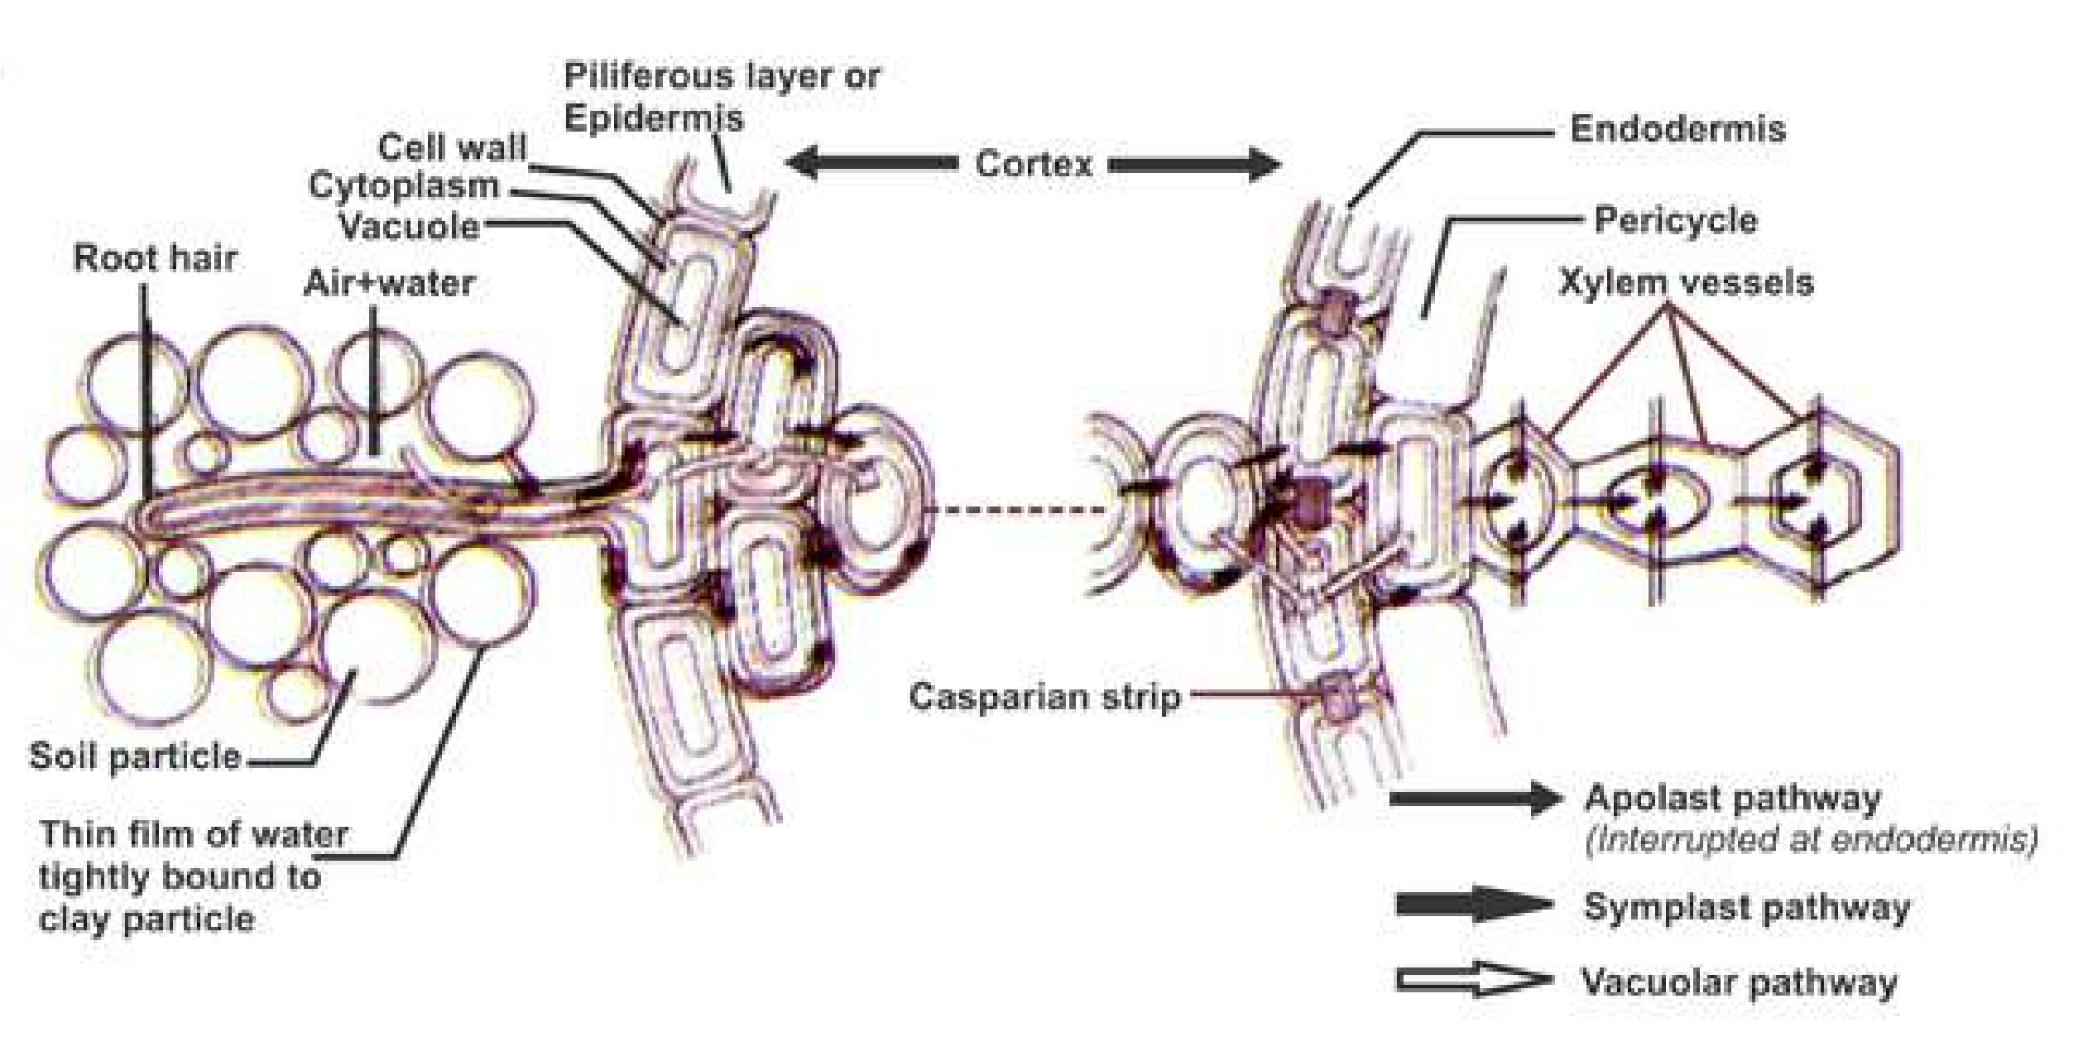

*Fig. 14.2 Diagrammatic representation of water and ion movement across a root showing transverse section. The apoplast pathway is of greatest importance for both water and solutes. The symplast pathway is less important, except for salts in the region of the endodermis. Movement along the vacuolar pathway is negligible.*

Following are the paths taken by water to reach the xylem tissue:

#### (i) The apoplast pathway

It is the pathway involving system of adjacent cell walls which is continuous throughout the plant roots. In the roots apoplast pathway becomes discontinuous in the endodermis due to the presence of casparian strips.

#### (ii) The Symplast pathway

It is the system of interconnected protoplasts in the root cells. The cytoplasm of neighbouring cells (Protoplasts) is connected with one another by Plasmodesmata which are cytoplasmic strands that extend through pores in adjacent cell walls. In the cells of root the cell membrane and cytoplasm (and plasmodesmata) can be regarded as acting together as one partially permeable membrane.

#### (iii) The vacuolar pathway

In this pathway water moves from vacuole to vacuole through neighbouring cells crossing the symplast and apoplast in the process and moving through cell membranes by osmosis. Water moves passively down a concentration gradient.

##### Water Potential (Symbolized By Greek Letter Psi = yw )

Water molecules possess kinetic energy which means that in liquid or gaseous form, they move about rapidly and randomly from one place to another. So, greater the concentration of the water molecules in a system the greater is the total kinetic energy of water molecules. This is called water potential (yw).

In plant cells two factors determine water potential.

i) Solute concentration (Osmotic or solute potential = ys) ii) Pressure generated when water enters and inlates plant cells (Pressure potential = yp).

Pure water has maximum water potential which by deinition is zero.

Water moves from a region of higher yw to lower yw .

All solutions have lower yw than pure water and so have negative value of yw (at atmospheric pressure and at a deined temperature). So **osmosis** can be deined as:

“The movement of water molecules from a region of higher water potential to a region of lower water potential through a partially permeable membrane”.

###### Osmotic (Solute) Potential = ys

The osmotic (solute) potential ys is a measure of the change in water potential(ys) of a system due to the presence of solute molecules. ys is always negative. More solute molecules present, lower (more negative) is the ys.

###### Pressure Potential (yp)

If pressure greater than atmospheric pressure is applied to pure water or a solution, its water potential increases. It is equivalent to pumping water from one place to another. Such a situation may arise in living systems.

When water enters plant cells by osmosis pressure may be built up inside the cell making the cell turgid and increasing the pressure potential. Thus the total water potential is sum of ys and yp.

###### yw = ys + yp water potential solute potential pressure potential

If we use the term water potential, the tendency for water to move between any two systems can be measured; not just from cell to cell in a plant but also from soil to root from leaf to air or from soil to air. The steeper the potential gradient the faster is the low of water along it.

The following example would help understand the concept of water potential. Two adjacent vacuolated cells are shown with yw, yp and ys.

*Fig. 14.3 Two adjacent vacuolated cells.*

*kPa= 1000 Pascals -*

**Q. a)** Which cell has the higher water potential? *which is the pressure*  **b)** In which direction will water move by osmosis? *exerted by a vertical*

1. What will be the water potential of the cells at equilibrium? *force of one Newtonon an area of 1 metre*
2. What will be the solute potential and pressure potential of the cells at *square.*  equilibrium?

##### Plasmolysis and Pressure Potential

Plasmolysis can be deined as the shrinkage of protoplast due to exosmosis of water. When a living cell is placed in a solution having lower water potential than that of the cell, plasmolysis takes place and the cell is called plasmolysed. If this plasmolysed cell is placed in distilled water (which has highest water potential) the water molecules would move from distilled water through diferentially permeable cell membrane into the cell, and the cell would become deplasmolysed.

The point at which plasmolysis is just about to happen is called **incipient plasmolysis**. At incipient plasmolysis the protoplast has just ceased to exert any pressure against the cell wall, so the cell is laccid.

If a plasmolysed cell is placed in distilled water, the one having higher water potential than the contents of the cell, water enters the cell by endosmosis, volume of protoplast increases, and it begins to exert pressure against the cell wall of plant cell. The cell wall is rigid - so the pressure exerted by the protoplast against the cell wall is called **pressure potential**. As the pressure potential of the cell increases due to endosmosis, the cell becomes turgid. Full turgidity i.e. maximum pressure potential is achieved when a cell is placed in pure water or distilled water.

The animal cells cannot withstand higher pressure potential as there is no cell wall around protoplast. Thus the turgid cells burst in a solution of higher water potential. So the animals employ the mechanism of osmoregulation to maintain the amount of water and salts in their cells to constant or nearly constant levels.

### ASCENT OF SAP

In the previous pages you have learned that water and dissolved minerals traverse the cortex and endodermis and reach the xylem tissue of roots. (Fig. 14.1,14.2) Actually, water and dissolved minerals are carried or pulled upwards towards the leaves through xylem tissue. This is called ascent of sap. This may involve the following :

#### (A) Cohesion Tension Theory (B) Root Pressure (C) Imbibition

**(A) Cohesion tension theory** is one of the most important theories proposed by Dixon. This theory provides a reasonable explanation of low of water and minerals upwards from the roots to leaves of plants, in bulk low or mass low (Fig. 14.5). This depends on the following:

1. **Cohesion:** It is the attraction among water molecules which hold water together, forming a solid chain-like column within the xylem tubes. The water molecules form hydrogen bonds between them.
2. **Tension:** It is provided when this water chain is pulled up in the xylem (Fig. 14.4). Transpiration provides the necessary energy or force. Tension is between the molecules of water by hydrogen bonds.

This xylem water tension is strong enough to pull water up to 200 metres (more than 600 feet) in plants.

1. **Adhesion:** It may be added that the water molecules also adhere to the cell walls of xylem cells, so that the column of water in xylem tissue does not break. The composition of cell wall provides necessary adhesion to water molecules that helps water creep up. The cellulose component of cell wall especially has great ainity for water. It can imbibe water.

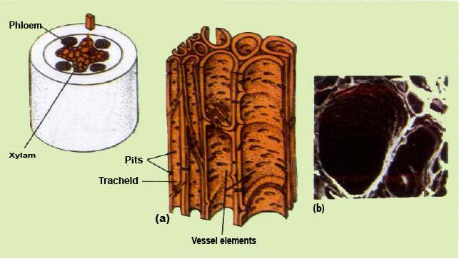

*Fig.14.4 (a) Xylem Tissue elements involved in transportation of water and dissolved minerals, (b) Scanning electron micrograph of two large vessel elements of a cucumber root.*

1. **Strong xylem walls:** It is essential that the xylem walls should have high tensile strength if they are not to buckle inwards. The lignin and cellulose provides strength to cell wall of xylem vessels (Fig. 14.4).

By cohesion-tension of water molecules, and the transpiration pull providing the necessary energy, the sap (water and minerals) in xylem tissue is pulled upwards to the leaves. Large quantities of water are carried at relatively high speed, upto 8mh-1 being recorded in tall trees, and commonly in other plants at 1mh-1.

The total water pulled up in the leaves is transpired, except about 1% which is used by plant in various activities including photosynthesis.

#### Mechanism of transpiration pull in cohesion tension theory

The evaporation of water from the aerial parts of the plant especially through stomata of leaves is a process called **transpiration**. As a leaf transpires the water potential of its mesophyll cells drops. This drop, causes water to move by osmosis from the xylem cells of leaf into dehydrating mesophyll cells. The water molecules leaving the xylem are attached to other water molecules in the same xylem tube by hydrogen bonds (cohesion of water molecules). Therefore, when one water molecule moves up the xylem, the process continues all the way to the root - where water is pulled from the xylem cells (tracheids and vessels). This pull also causes water to move down its concentration gradient transversely from the root epidermis (root hairs) to cortex by endosmosis and to pericycle. This pulling force or transpiration pull is so strong that it also reduces the water potential of root epidermal cells. Then water in the soil moves from its higher water potential to lower water potential of epidermis of root by osmosis.

*Animation 14.3*

[*:*](https://www.youtube.com/watch?v=Dtsen_YNwVk)

*Transpiration pul*

[*l*](https://www.youtube.com/watch?v=Dtsen_YNwVk)

*Source and Credit:*

*g*

*ifsoup*

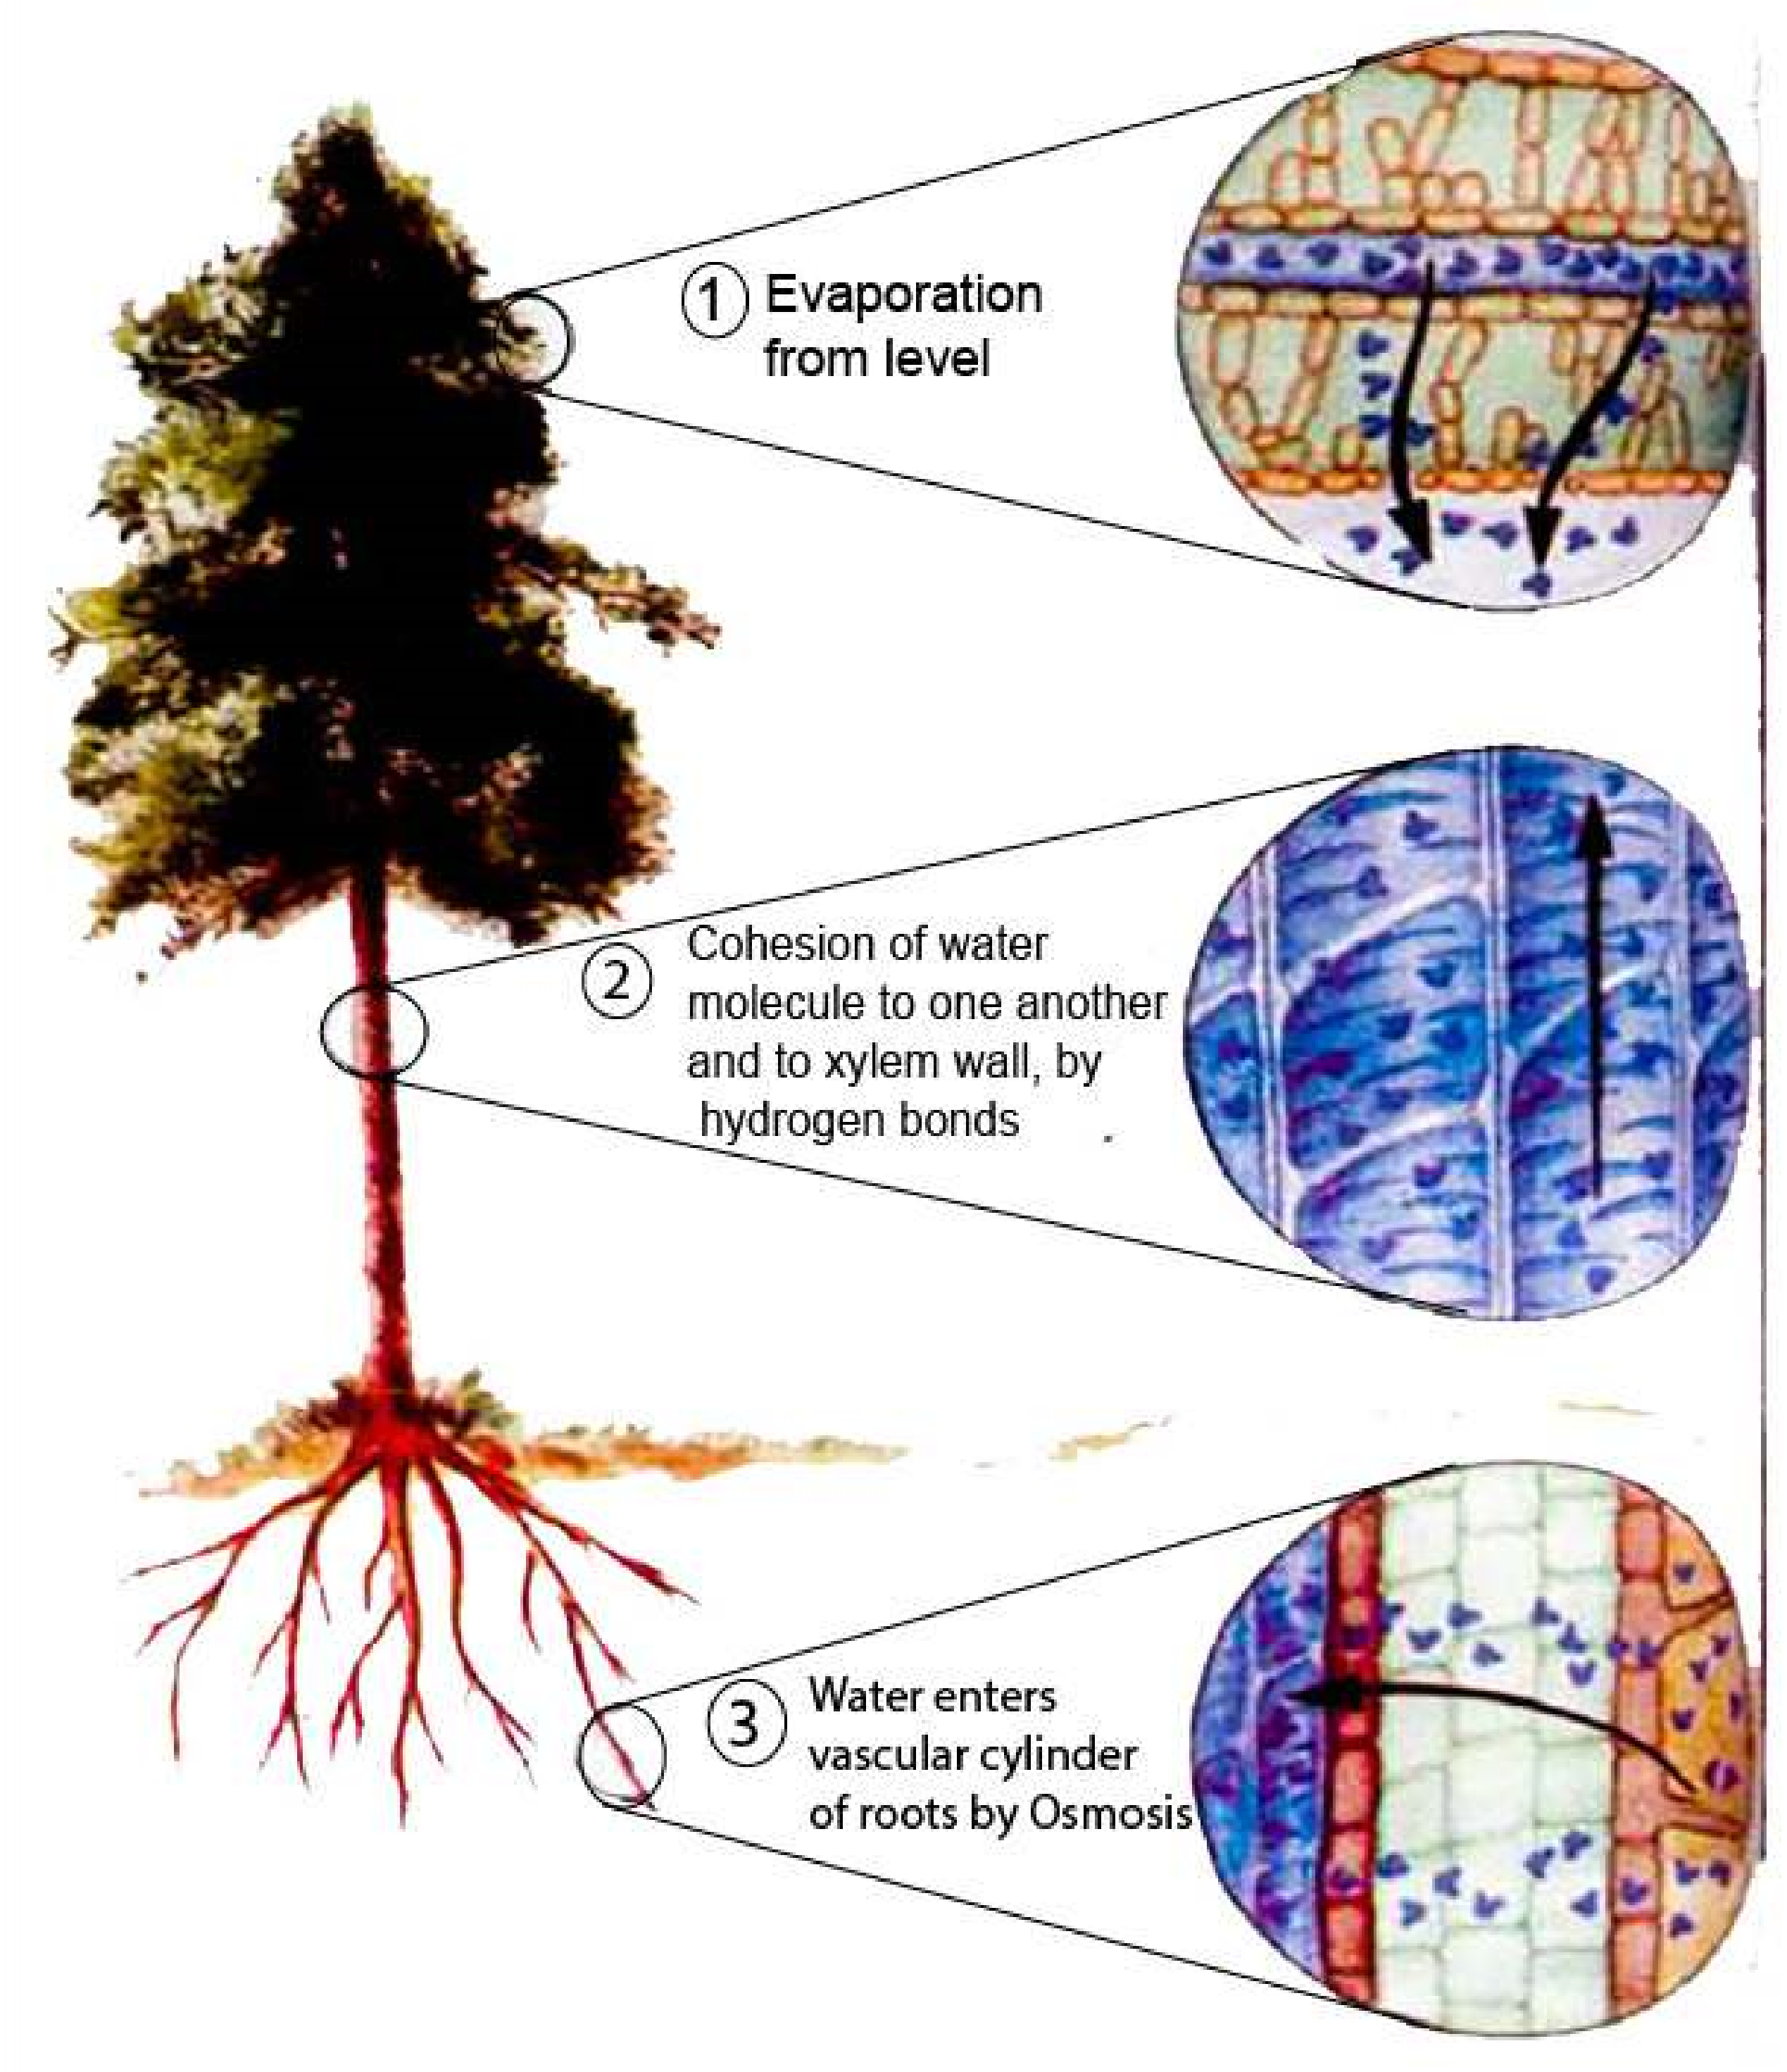

*Fig.14.5 The cohesion-tension theory of water low from root to leaf.*

1. **Root pressure :** Second force involved in the movement of water and dissolved minerals up in the xylem tissue is the root pressure. Root pressure is created by the active secretion of salts and other solutes from the other cells into the xylem sap. This lowers the water potential of xylem sap. Water enters the xylem cells by osmosis, thus increasing the level of sap in the xylem cells. Water entering the xylem cells, may take apoplast, symplast or vacuolar pathway increasing the hydrostatic pressure in cells, this pushes the water upwards. As a result of root pressure the sap in the xylem does not rise to enough height in most plants. The root pressure is also least efective during the day, when transpiration pull is the active force involved in pulling the sap in xylem cells upwards. It has been estimated that a positive hydrostatic pressure of around 100 to 200 KPa (exceptionally 800 KPa) is generated by root pressure. The pressure mentioned above is not enough to push water upwards to required height in most plants. But it is no doubt a contributing factor in plants which transpire slowly, and are smaller in size.

Closely associated with root pressure is a phenomenon called guttation or exudation. Guttation is loss of liquid water through water secreting glands or hydathodes. The dew drops that can be seen on the tips of grass leaves or strawberry leaves are actually guttation droplets exuded from hydathodes. (Fig. 14.6).

Guttation or exudation is more notable when transpiration is suppressed, and the relative humidity is high as at night. The guttation is in fact due to positive pressure - the root pressure, developed in xylem tissue of roots.

*Fig. 14.6 Guttation by stawberry leaves*

1. **Imbibition :** Another important force in the ascent of sap is imbibition. Sacks in 1874 sugested that the water molecules move along the cell walls of xylem vessels due to imbibition.

The cell wall components especially cellulose, pectin and lignin can take up water and as a result increase in volume, but the components do not dissolve in water, this is called imbibition. The amount of attraction and increase of dry cell walls of plant cells, and of protoplasm for water is often very great and considerable imbibition forces may be developed in plant body. The root cell walls imbibe water from the soil, and this water moves by apoplast pathway already discussed.

Imbibition is a reversible process and when water is lost the original volume of cell wall and of protoplasm is restored. The uptake of water by imbibition is especially important in germinating seeds. The volume of dry seed may increase up to 200 times by imbibition, as a result, the seed coat ruptures and makes the germination of seed efective.

**Bleeding :** Sometimes it so happens that certain plants, when cut, pruned, tapped or otherwise wounded, show a low of sap from the cut ends or surfaces quite often with a considerable force. This phenomenon is commonly called **bleeding**.

It is often seen in many land plants in the spring, particularly grape wine, some palms, sugar maple etc.

Although the low of sap is ordinarily slow, a considerable quantity of the sap within a period of 24 hours comes out of the plant. In some palms when tapped, there may be a low of sap to the extent of 10-15 litres per day. The sap in such plants contains sugars and water in addition to organic and inorganic substances (e.g. salts).

There are two main factors responsible for bleeding, the hydrostatic pressure in xylem and phloem elements, and the root pressure, which is exerted by the xylem tissues of roots.

### TYPES OF TRANSPIRATION

You have already studied the role of transpiration, in ascent of sap.

There are three types of transpiration depending upon the route of escape of water vapours from the aerial parts of the plant.

(i) Cuticular transpiration (ii) Lenticular transpiration (iii) Stomatal transpiration

*Animation 14.4*

[*:*](https://www.youtube.com/watch?v=Dtsen_YNwVk)

*Transpiratio*

[*n*](https://www.youtube.com/watch?v=Dtsen_YNwVk)

*Source and Credit:*

*a*

*tmos.uiu*

[*c*](http://ww2010.atmos.uiuc.edu/(Gh)/guides/mtr/hyd/trsp.rxml)

1. **Cuticular transpiration :** The loss of water in the form of water vapours through the cuticle of leaves is called cuticular transpiration. About 5-7% of total transpiration takes place through this route.

The cuticle present on the upper and lower epidermis of leaves is not completely impermeable to water and some water is lost in the form of vapours through cuticle. The thinner the cuticle the greater is the rate of transpiration; although the composition of cuticle is also important. At night, when the stomata are almost closed, cuticular transpiration takes place. Most of the factors which afect rate of transpiration, in general, are also important in controlling the rate of cuticular transpiration.

1. **Lenticular transpiration :** Lenticular transpiration is the loss of water vapours through lenticels present in the stem of some plants. (Fig. 14.7) All plants do not possess lenticels.

The lenticular transpiration is 1-2% of the total transpiration by a plant. These openings, like stomata,are also involved in the exchange of gases between environment. When there is strong light and high temperature,the loss of vapours is rapid because it is governed by difusion.

Lenticels are aerating pores formed in the bark through which exchange of gases takes place, and water is lost in the form of water vapours (transpiration). Externally, they appear as scars or small protrusions on the surface of stem. Lenticel consists of a loose mass of small, thin-walled cells. At each lenticel the cork cambium forms oval, spherical, or irregular cells, which are very loosely arranged, having lots of intercellular spaces.

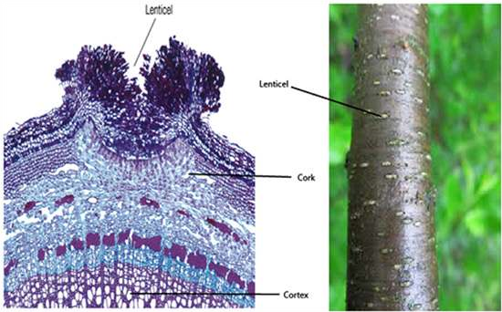

*Fig. 14.7 Left : The waterproof outer bark (layer of dark cells on the surface) on this section of stem is interrupted at the center of the lenticel. Thus the more loosely arranged cell layer beneath, with their numerous intercellular air spaces, are exposed to the atmosphere, Right: The individual lenticels can be seen as white areas on the surface of a young stem.*

1. **Stomatal transpiration :** It is a type of transpiration in which the water vapours escape through stomata. In isobilateral leaves the stomata are present, in both, upper and lower epidermis e.g. lily and maize leaf. In dorsiventral leaves the stomata are conined to only the lower epidermis.

The guard cells are normally dumble or bean-seed-shaped. The inner concave sides of two guard cells enclose the stoma. This inner side of guard cell has very thick cell wall, but the outer convex side has thin cell wall. The guard cells are the only cells, of leaf epidermis, which are not connected by plasmodesmata to other epidermal cells, and which have chloroplasts - and thus are involved in the process of photosynthesis (Fig. 14.8). When these guard cells are turgid, the stoma between them opens and when the guard cells are laccid the stoma between them closes. The degree of opening of stomatal pores also afects the rate of transpiration. 90% of total transpiration in a plant is stomatal.

The cells of mesophyll of leaf provide enormous surface ‘area for the loss of water in the form of vapours. The pathway of water vapours loss to the atmosphere, through stomata is shown. (Fig.

14.8)

*Fig.14.8 The water pathway through the leaf. Water is drawn from the xylem into the cell walls of the mesophyll, where it evaporates into the air spaces within the leaf. By difusion, water vapour then moves through the leaf air space, through the stomatal pore, and across the boundary layer of still air that adheres to the outer leaf surface. C02 also difuses into the leaf through stomata along a concentration gradient.*

### OPENING AND CLOSING OF STOMATA

The guard cells function as multisensory hydraulic valves (Fig. 14.9). Environmental factors, such as light intensity and quality, temperature, relative humidity, and intracellular CO2 concentration are sensed by guard cells and these signals are integrated into well-deined stomatal responses.

There are two hypotheses which may explain the opening and closing of stomata.

1. **Starch Sugar Hypothesis :** The German botanist H. Van Mohl proposed that the guard cells are the only photosynthesising cells of epidermis of leaf and sugars are produced in them during day time when light is available. When sugar level rises i.e. solute concentration increases or water potential decreases - and the guard cells become turgid due to entry of water and they separate from one another, and stoma or pore opnes. During night there is no photosynthesis the sugars are either converted into insoluble starch or are used in respiration, this decreases free sugars in cell. So the osmotic pressure of guard cells is lowered, and water leaves the guard cells, which become laccid and stoma or pore between them closes. But these processes are not fast enough to account for the rapid rise in turgor, of guard cells.
2. **Inlux of K+ ions :** Potassium concentration in guard cells increases several fold, depending upon plant species.

Stomata open due to active transport of potassium ions (K+) into the guard cells from the surrounding epidermis. The accumulation of K+ decreases the osmotic potential of guard cells. Water enters the guard cells by osmosis, which become more turgid and stretched and stomata are opened. The stoma closes by reverse process; involving passive difusion of K+ from guard cells followed by water moving out by osmosis. What controls the movement of K+ into and out of guard cells? Level of carbon dioxide in the spaces inside the leaf and light, control this movement. A low level of carbon dioxide favours opening of the stomata, thus allowing an increased carbon dioxide level and increased rate of photosynthesis.

Exposure to blue light, which is also efective in photosynthesis has been shown to acidify the environment of the guard cells (i.e. pumps out protons) which enable the guard cells to take up K+ followed by water uptake resulting in increased turgidity of guard cells. So in general stoma are open during day and closed at night. This prevents needless loss of water by the plant when it is too dark for photosynthesis.

The plants open their stomata by actively pumping Potassium in guard cells causing water to follow by osmosis. Guard cells become turgid and stoma or pore opens. When Potassium leaves the guard cells (during night) water leaves the guard cells by exosmosis and guard cells become laccid and stoma or pore between guard cells closes.

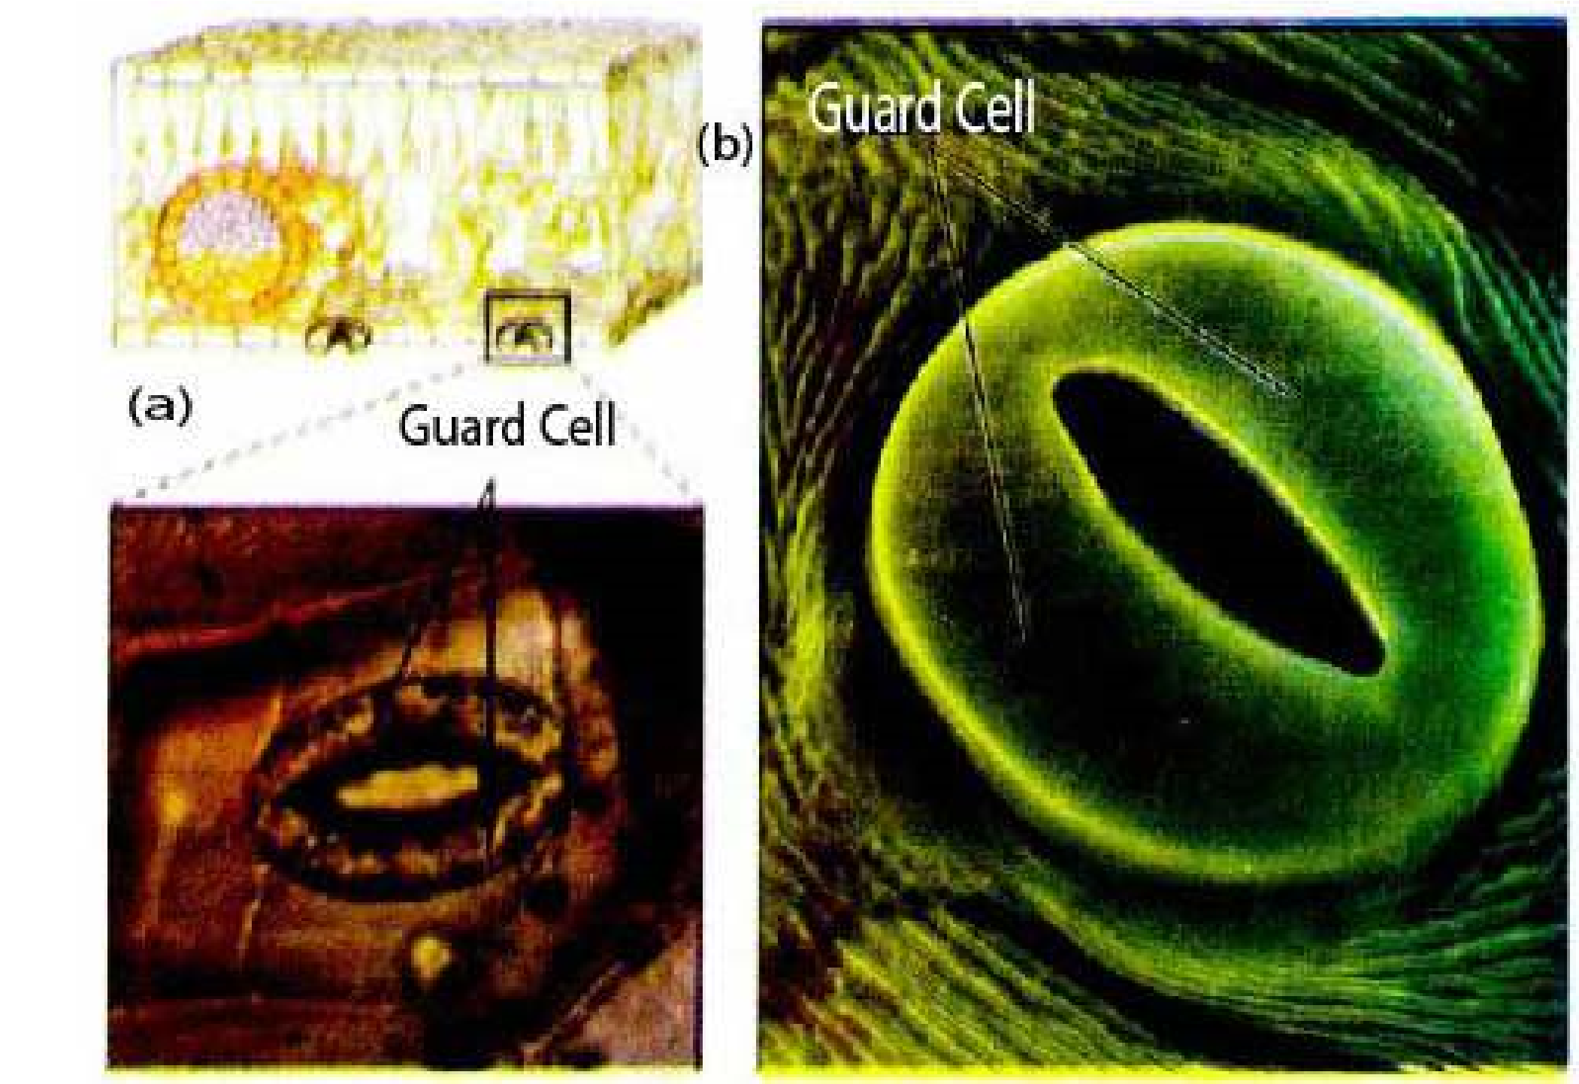

*Fig 14.9 Stomata . Stomata seen through (a) the light microscope and (b) scanning electron microscope. In the light micrograph, note that the guard cells contain chloroplasts (the green ovals within the cells) but that the other epidermal cells do not.*

*Animation 14.5*[*: Stomata*](https://www.youtube.com/watch?v=Dtsen_YNwVk)

*Source and Credit:* [*g*](https://www.youtube.com/channel/UCq4OErD4v1bo3dg0agqUC6g)[*ifsoup*](http://gifsoup.com/view/3142480/stoma.html)

#### Factors affecting the rate of transpiration

Rate of transpiration for a plant is very important as the transpiration stream is necessary to distribute dissolved mineral salts throughout the plant. Water is transported to photosynthesizing cells of leaves. Transpiration is also very important as it cools the plant. This is especially important in higher temperatures. If the rate of transpiration is very high, there would be much loss of water from the plant, so at high temperatures the stomata almost close and reduction in the rate of transpiration is efected. This stops wilting of the leaves and of plants (herbaceous plants).

There are some important factors which afect the rate of transpiration in a plant.

(i) Light (ii) Temperature

(iii) CO2 concentration (iv) Humidity and vapour pressure (v) Wind and (vi) Availability of soil water.

1. **Light :** The opening and closing of stomata is directly controlled by the light. In strong light the rate of transpiration is much more as compared with that in dim light or no light. As Potassium actively enters the guard cells, when light is available, water follows - and guard cells become turgid, and stoma opens.
2. **Temperature:** When the sun-light is strong on a bright and sunny day the environmental temperature is increased. The higher temperature reduces the humidity of the surrounding air. The evaporation of water from the surfaces of mesophyll cells also increases, thus increasing the rate of transpiration.

The rate of transpiration doubles by every rise of 10°C in temperature. Very high environmental temperature, i.e. 40-45°C cause closure of stomata, so that plant does not loose much needed water.

If higher temperatures are maintained in the environment *Hormones are involved in stomatal movement in* for a longer duration and soil water is limited, the plants *plants. At high temperature when leaf cells start* would wilt and may die. *wilting a hormone is released by mesophyll cells.This hormone is called abscisic acid. This hormone stops the active transport of K+ into guard cells,* **iii) Carbon dioxide concentration :** Low carbon *overriding the efect of light and C0+ 2concentration.*

dioxide concentration (such as those that occurs during the *So K pumping stops. Stomata close.*

day when photosynthesis exceeds respiration), stimulates the active transport of Potassium ions into the guard cells. This transport (as discussed earlier) causes stomata to open and allow C02 to difuse in the mesophyll cells of leaves. At night cellular respiration in the absence of photosynthesis raises C02 levels. This halts the inward transport of K+, and thus of water, allowing the guard cells to become laccid and stomata close. Thus transpiration almost stops.

1. **Humidity and vapour pressure :** When air is dry, the rate of difusion of water molecules, from the surfaces of mesophyll cells, air spaces, and through stomata to outside the leaf, increases (Fig. 14.8). So more water is lost, increasing the rate of transpiration. In humid air the difusion rate is reduced. This decreases the rate of transpiration appreciably.
2. **Wind :** The air in motion is called wind, which causes increase in rate of difusion of water molecules. The rate of evaporation from the surfaces of mesophyll cells increases. When air is still, the rate of movement of water molecules (difusion) is slowed down, thus reducing the rate of transpiration.
3. **Availability of soil water :** If there is little water in the soil, less is brought or transported to the leaf cells and less is lost to the environment by transpiration. So when the rate of absorption of water in root cells is reduced, the rate of transpiration is reduced.

#### Transpiration as a necessary evil

Transpiration has been described as necessary evil because it is an inevitable, but potentially harmful consequence of the existence of wet cell surfaces from which evaporation occurs. Loss of water from the plant can lead to wilting, serious desiccation and often death of a plant if conditions of drought are experienced. There is good evidence that even mild water stress results in reduced growth rate and in crops to economic losses through reduction of yield.

Despite its apparent inevitability it is also of very great importance for the plant.

i) Water is conducted or transported in most tall plants with the courtesy of transportation pull. ii) Minerals dissolved in water are distributed throughout plant body by transpiration stream. iii) Evaporation of water from the exposed surface of cells of leaves has cooling efect on plant. iv) Wet surface of leaf cells allow gaseous exchange.

### TRANSLOCATION OF ORGANIC SOLUTES

Organic solutes are transported by phloem tissue.

#### Phloem Transport

The phloem is generally found on the outer side of both primary and secondary vascular tissue in plants with secondary growth. The phloem constitute the inner bark. The cells of phloem thatconduct or transport sugars and other organic material throughout the plant are called sieve elements.

In addition to sieve elements, phloem tissue also contains companion cells, parenchyma cells, and in some cases ibres, sclereids and latex containing cells. However, only sieve tube cells are directly involved in transport of organic solutes.

Sieve elements are characterised by ‘sieve areas’ portions of the cell wall where pores interconnect the conducting cells. Some of the sieve areas of sieve tube members are generally formed in end walls of sieve tube members where the individual cells are joined together to form a longitudinal series called a sieve tube. Sieve plate pores of sieve tubes are essentially open channels, that allow transport between cells (Fig. 14.10).

*Fig. 14.10 (a) This diagram shows part of the root phloem consisting of sieve tube members stacked end to end. Adjoining end walls have common pores. Each sieve tube member is associated with a companion cell (b) Sieve tube member showing the pores in its end walls. Note the scarcity of cytoplasmic components in these sugar conducting cells.*

Each sieve tube member is associated with one or more companion cells. Sieve tubes and companion cells are in communication with each other by plasmodesmata. Companion cells supply ATP and proteins to sieve tubes. The photosynthetic products from photosynthesizing cells, the mesophyll and palisade layer of leaf, pass into sieve tubes, through the companion cell via plasmodesmata.

#### Patterns of Transport

Phloem transport does not occur exclusively in an upward or a downward direction and is not deined with respect of gravity. Transport or translocation occurs from the areas of supply (sources) to areas of metabolism or storage (sinks).

The areas of sources include any exporting organ typically a mature leaf, or storage organ, that is capable of

i) Storing photosynthate in excess of its own needs. ii) Storage organ during the exporting phase of its development. In biennials e.g root of beet is a sink in irst growing season, but becomes source in the *The composition of materials lowing in phloem has* next growing season, when sugars are utilized in growth *been studied by using aphids - the insects which are* of new shoots. *phloem feeders (Fig 14.11). These insects insert their* iii) Sinks are the areas of active metabolism or storage *stylets into stem or leaf and extend them to puncturea sieve tube. The pressure in the sieve tube cell forces* for example roots, tubers, developing fruits, immature *sap through aphid’s digestive tract and out its posterior* leaves, and even the growing tips of stem and root. *end as droplets called “honey dew”. The composition ofhoney dew have revealed that it contains 10-25% dry matter 90% or more of which is sucrose. Nitrogenous* The movement in phloem is from source to sinks in most *compounds are about 1%.* of the plants during active photosynthesis.

*Animation 14.6 Absorptive Root*

*Source & Credit:* [*cas.miamioh*](http://www.cas.miamioh.edu/~meicenrd/anatomy/Ch8_Absorptive/Absorptive.html)

*Fig.14.11 Collection of phloem sap using aphids*

#### The Mechanism of phloem translocation/transport

The theory called, Pressure - Flow Theory, is the most acceptable theory for the transport in the phloem of angiosperms. We have considerable evidence to support this theory. There were two main categories of theories to account for movement of sap in phloem. The active theories involving the use of energy for the movement of materials in phloem, and the passive theories in which no use of energy was involved. The active theories have all been abandoned as there is not much evidence to support these theories.

Now we are left with passive theories of transport / translocation. These include:

(**i)** Difusion (**ii)** Pressure low theory

1. **Difusion:** is far too slow, to account for the velocities of sugar movement in phloem, which on the average is 1 metre per hour, while the rate of difusion is 1 metre per eight years. So we are left with pressure low theory.

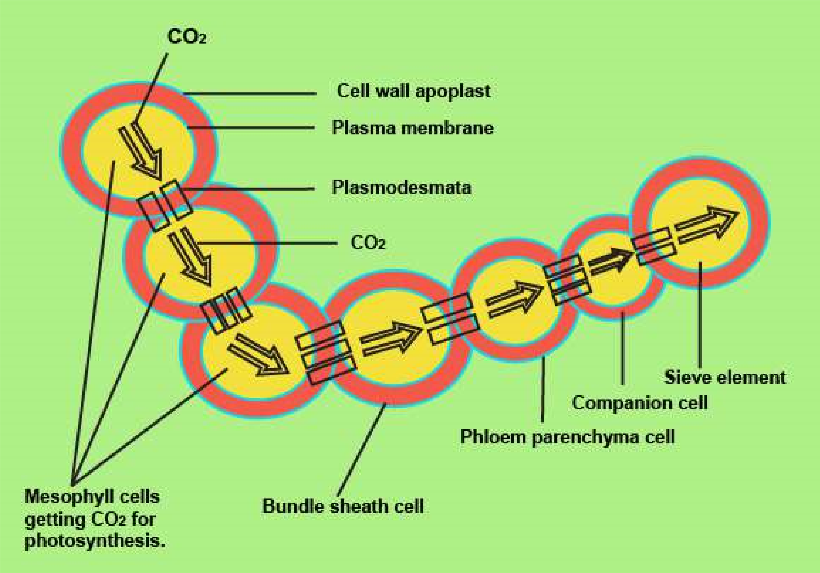

*Fig.14.12 Movement of sugars from mesophyll cells to sieve elements.*

1. **Pressure low theaory:** A hypothesis was irst proposed by Ernst Munch in 1930. It states that the low of solution in the sieve elements is driven by anosmotically generated pressure gradient between””source and sink. Now this hypothesis has been given status of a theory. See Fig. 14.13, the following steps,explain pressure low theory.

(1) The glucose formed in the photosynthesizing cells, is used within the cells (for respiration etc.) and the rest is converted into non-reducing sugar i.e. sucrose. (2) This sucrose is actively transported through the bundle sheath cells to the companion cell of the smallest vein in leaf, a short distance transport (involving 2 - 3 cells). Thus sucrose difuses through plasmodesmata to sieve tube cell or sieve element, raising the concentration of sucrose in it. (Fig. 14.12) The pathway taken by sucrose is symplast in most cases; but is some, apoplastic movement does take place. The sucrose is actively transported to the sieve elements. (3) The water moves by osmosis from the nearby xylem in the leaf vein. This increases the hydrostatic pressure of the sieve tube element.

1. Hydrostatic pressure moves the sucrose and other substances in the sieve tube cells, and moves to sinks e.g. fruits and roots. In the storage sinks, such as sugar beet root and sugarcane stem, sucrose is removed into apoplast prior to entering symplast of the sink.
2. Water moves out of sieve tube cell by osmosis, lowering the hydrostatic pressure.

In symplastic pathway, sucrose (or sugars) move through plasmodesmata to the receiver cell. Thus according to pressure low theory, the pressure gradient is established as a consequence of entry of sugars in the sieve elements at the source; and removal of sugars (sucrose) at the sink (Fig. 14.13). The energy driven entry of sugars in sieve tube elements, generate high osmotic pressure in the sieve tube elements of the source causing a steep drop in the water potential.

1. The presence of sieve plates greatly increases the resistance along the pathway and results in the generation and maintenance of a substantial pressure gradient in the sieve elements between source and sink.

The sieve element’s contents are physically pushed along the transportation pathway by bulk low, much like water lowing through a garden hose.

The pressure low theory accounts for the mass low of molecules within phloem. It may be noted that the transpertation of photosynthate or carbohydrates from the mesophyll cells to phloem tissue involves difusion and active transport (carrier mediated transport). Then in phloem tissue (sieve tubes) the movement of materials is according to pressure low theory.

Again in the sink cells when the sugar and the carbohydrates are passed from the phloem tissue, difusion and carrier mediated transport, either passive or active, takes place, (see table 14.1).

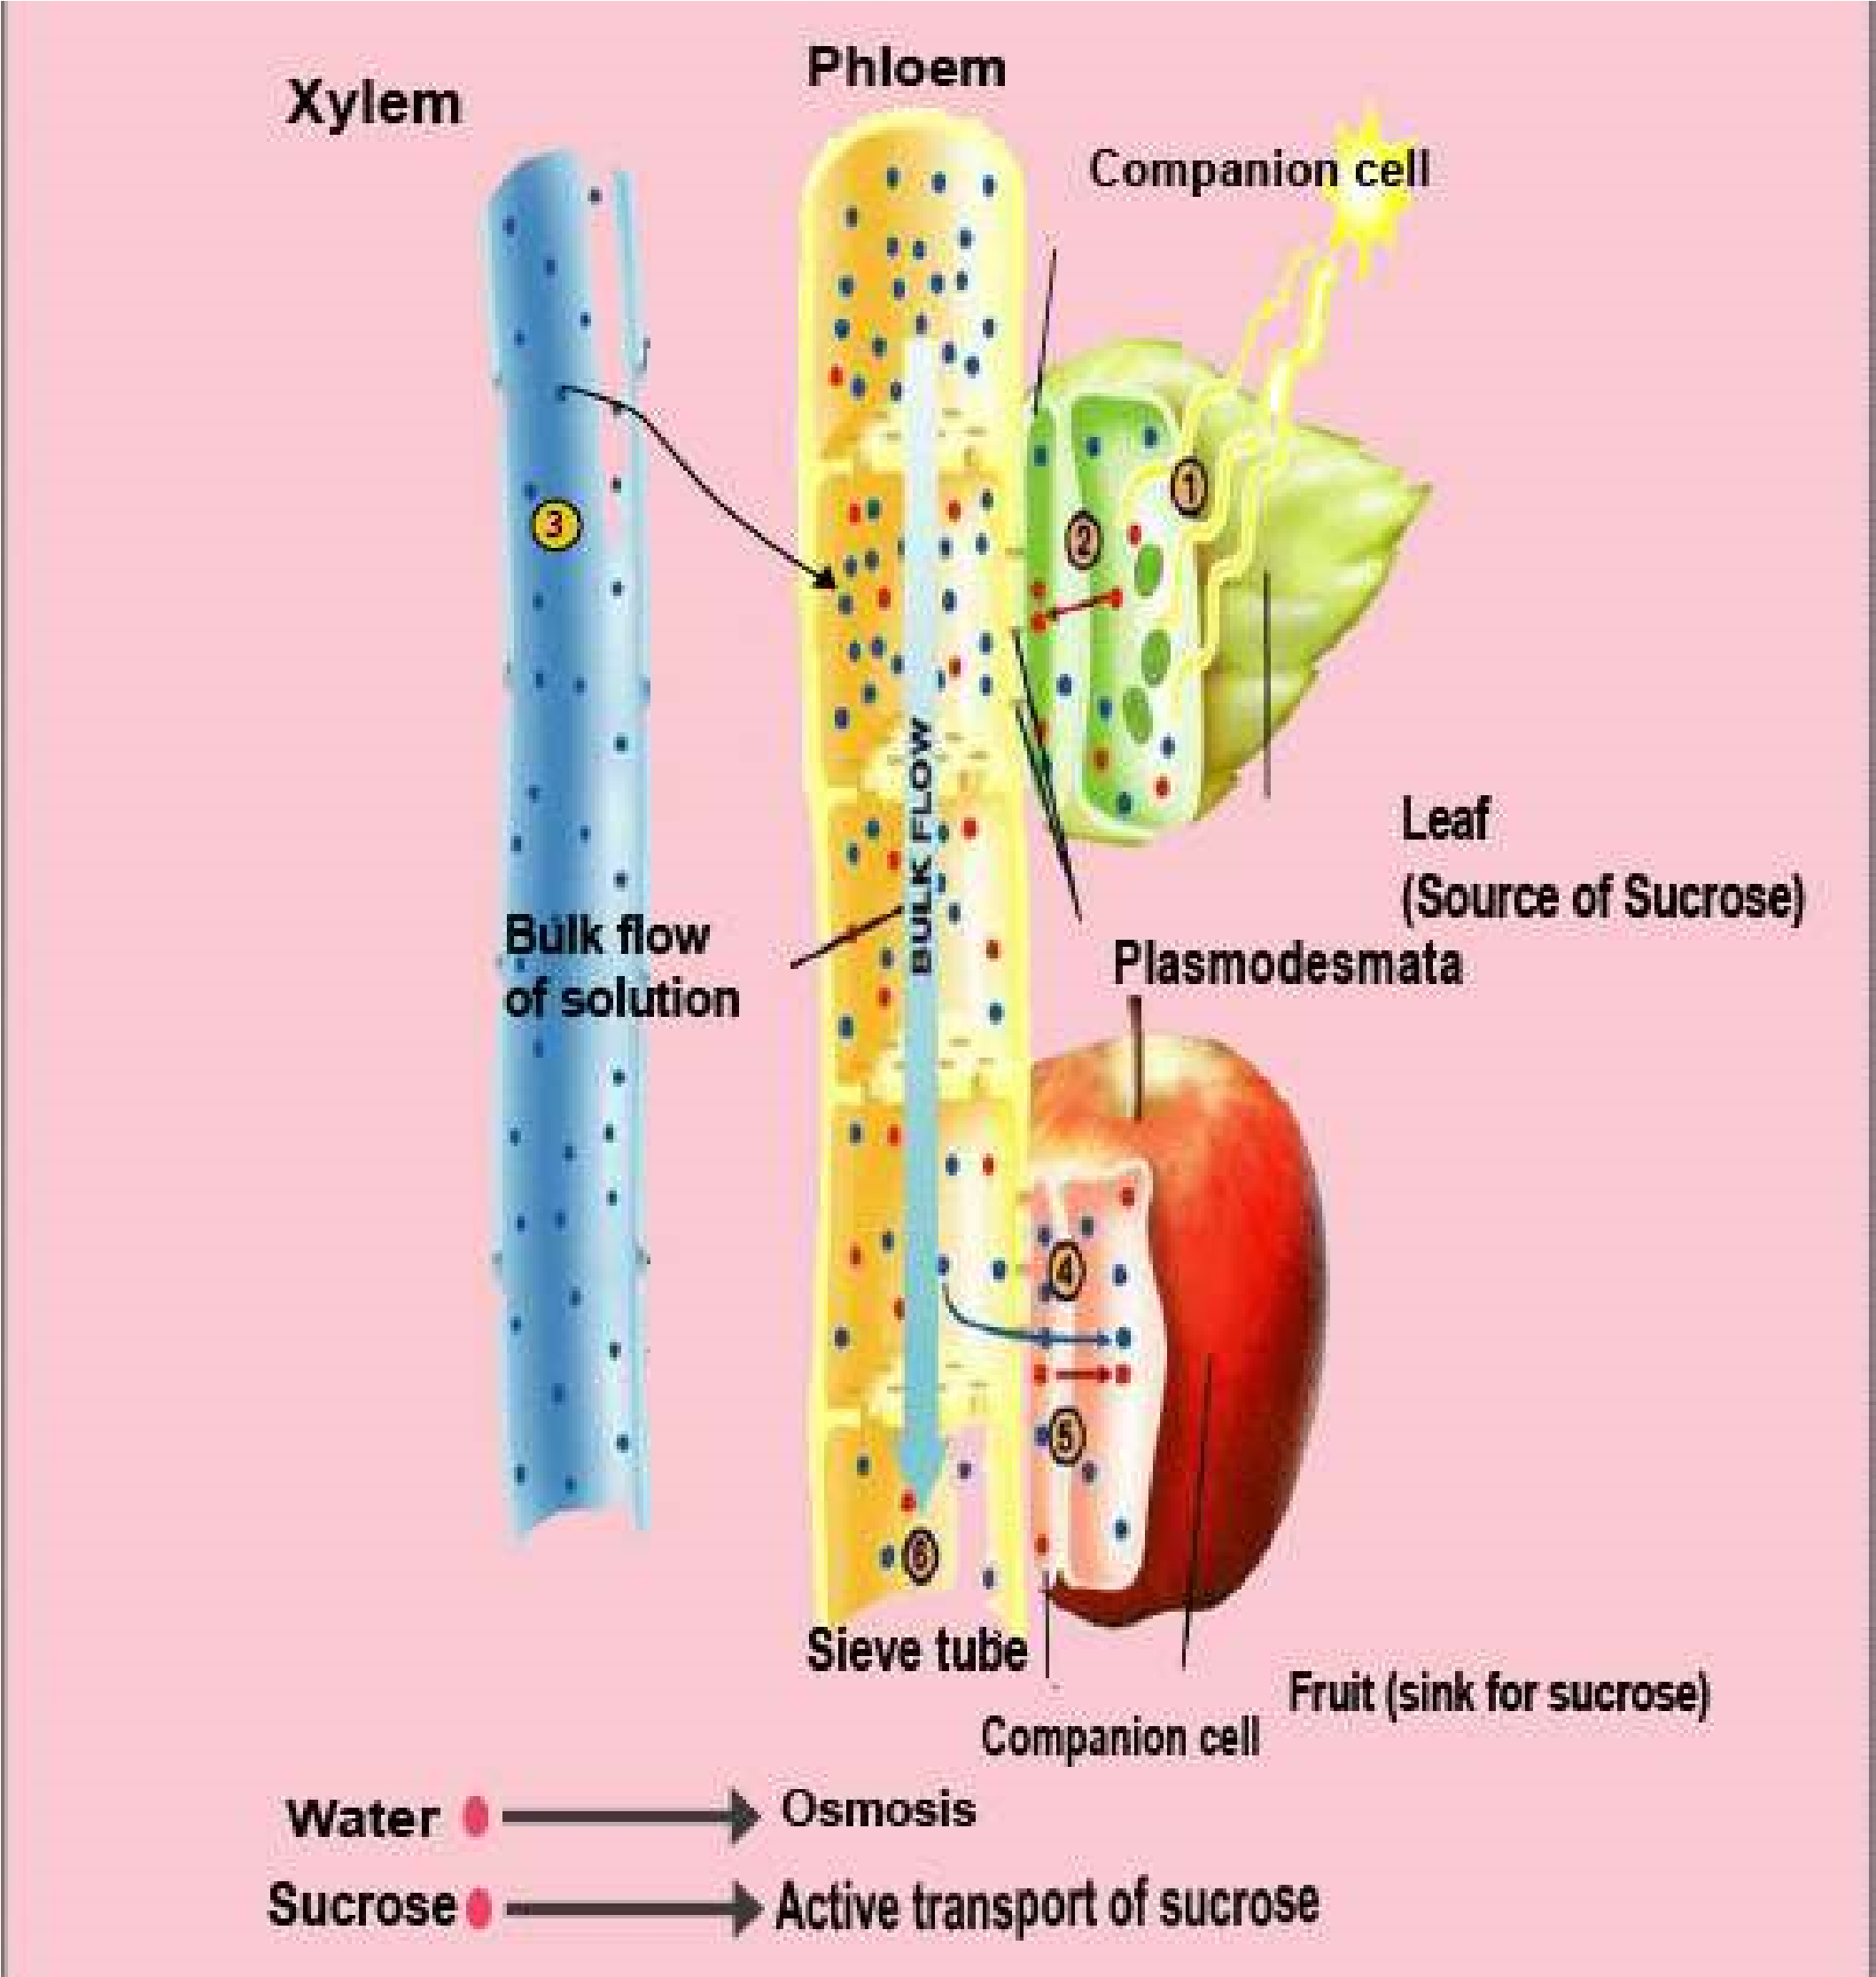

*Fig. 14.13 The Pressure-low theory (1) A photosynthesizing leaf manufactures sucrose (red dots), which (2) is actively transported (red arrow) into a nearby companion cell. The sucrose difuses to sieve-tube element through plasmodesmata, raising the concentration of sucrose. (3) Water (blue dots leaves nearby xylem and moves into the “leaf end” of the sieve tube by osmosis (blue arrow), raising the hydrostatic pressure. (4) The same sieve tube connects to a developing fruit (sink); sucrose enters the companion cells by difusion through plasmodesmata. It is then actively transported out of the companion cells and into the fruit cells. (5) Water moves out of the sieve tube by osmosis, lowering the hydrostatic pressure within the tube. (6) High pressure in the leaf end of the phloem and low pressure in the fruit end cause water, together with any dissolved solutes, to low in bulk from leaf (source) to fruit. (Black arrow).*